**COMMON MEDICAL CONDITIONS IN CHILDREN**

1. Children at risk of perioperative respiratory adverse events (PRAE)
   1. The child with runny nose
   2. The wheezy child
   3. The child with sleep disordered breathing/ obstructive sleep apnoea
2. The child with a murmur
3. The child with challenging behavior
4. The Autistic child
5. The Child with cerebral palsy / brain impaired
6. The Child with Down Syndrome
7. **Children at risk of perioperative respiratory adverse events (PRAE)**Children having a general anaesthetic can have various respiratory adverse events such as airway obstruction, breath holding, atelectasis, desaturation, coughing, stridor, laryngospasm and bronchospasm. These events can lead to severe hypoxia and cardiac arrest.

Hence it is important to identify children with risk factors that can predispose to respiratory adverse events during general anaesthesia with the aim of,

1. Informing the patients/parents about the risks of general anaesthesia
2. Discussing the benefits and risks of general anaesthesia with the surgeons
3. Discuss benefits and risks of rescheduling general anaesthesia
4. Preoperative preparation of the patient and operating theatre to minimize the risks and manage adverse events effectively.

Factors predisposing to higher risk of peri-operative respiratory adverse events in children having a general anaesthetic include the following:

1. Patient factors:
2. Upper respiratory tract infection (URTI) – ongoing or within 2 weeks of general anaesthesia
3. Dry nocturnal cough
4. Obstructive sleep apnoea
5. Current or previous history of eczema
6. Asthma
7. Prematurity and bronchopulmonary dysplasia
8. Cystic fibrosis
9. Pulmonary hypertension
10. RSV bronchiolitis
11. Any other infections (with fever>38.5 degree centigrade, malaise.)
12. Family history of asthma
13. Family history of eczema
14. Family history of hay fever
15. Passive smoking
16. Obesity (>95th percentile weight for the given age and sex)

Younger age (< 6 years, particularly < 1 year, decreasing age by each year increases the risk by 11%).

1. Surgical factors:
2. Urgent/emergent procedures
3. Airway, ear nose throat, eye surgeries
4. Anaesthetic factors:
5. Inexperience with paediatric anaesthesia
6. Anaesthetic agents (desflurane> sevoflurane> propofol)
7. Airway management (Endotracheal tube > LMA > Facemask)
8. **The Child with Runny Nose**

The questions we have to consider are:

* What is the cause: vasomotor/allergic rhinitis or infective
* What complications might happen
* What are the risks in proceeding – risk vs benefit
* How to proceed

What is the cause?

Signs and symptoms of a respiratory tract infection include fever, malaise, poor feeding, headache, irritability, cough, nasal congestion and discharge. Conversely, a history of atopy and wheezing in the absence of systemic symptoms and signs like fever and malaise, may suggest an allergic cause.

What complications may happen in the presence of an upper respiratory tract infection (URTI)?

There is increased risk of laryngospasm, bronchospasm and hypoxaemia perioperatively. Increased secretions and mucus plugging of the airways can occur. A rare but serious complication is myocarditis and arrhythmias. The increased sensitivity of airways may persist for up to 6-8 weeks post upper respiratory tract infection.

Risk vs. Benefit:

The risk of PRAEs is increased, particularly if there are additional risk factors. However, there may be the need to proceed with emergency surgery even in the face of a URTI while taking measures to prevent and treat complications that may arise. Parents should be counseled on the risks appropriately. Elective surgery may proceed if the cause of runny nose is non-infective and the child optimised as much as possible (this does not necessarily equate symptom free). This is especially so if the surgery may improve symptoms of airway

obstruction. Again, the anaesthetist, surgeon and parents need to be aware of possible complications and hospital admission in event of serious complications arising, particularly if the case was planned as day surgery.

How to proceed:

1. All children with signs and symptoms of URTI should be postponed for at least 2 weeks if the surgery is not urgent.
2. If the child has only a runny nose with clear discharge or nasal congestion, we may proceed if the child looks well, and the surgery is minor and will not require tracheal intubation. Laryngeal mask airway (LMA) may be used but the depth of anaesthesia must be adequate prior to placement to avoid possibility of laryngospasm.
3. If emergency surgery must proceed in a child with URTI, precautions must be taken. The maintenance of adequate anaesthetic depth in accordance with the degree of surgical stimulation is imperative. The risk is lower with:
4. the use of intravenous induction

* maintenance of anaesthesia with inhalational agents except desflurane
* airway management by a paediatric anaesthesia specialist
* the use of facemask/supraglottic airway device like LMA instead of tracheal intubation
* Salbutamol premedication for kids with URTI

In the postoperative period, the child may require humidified oxygen and physiotherapy

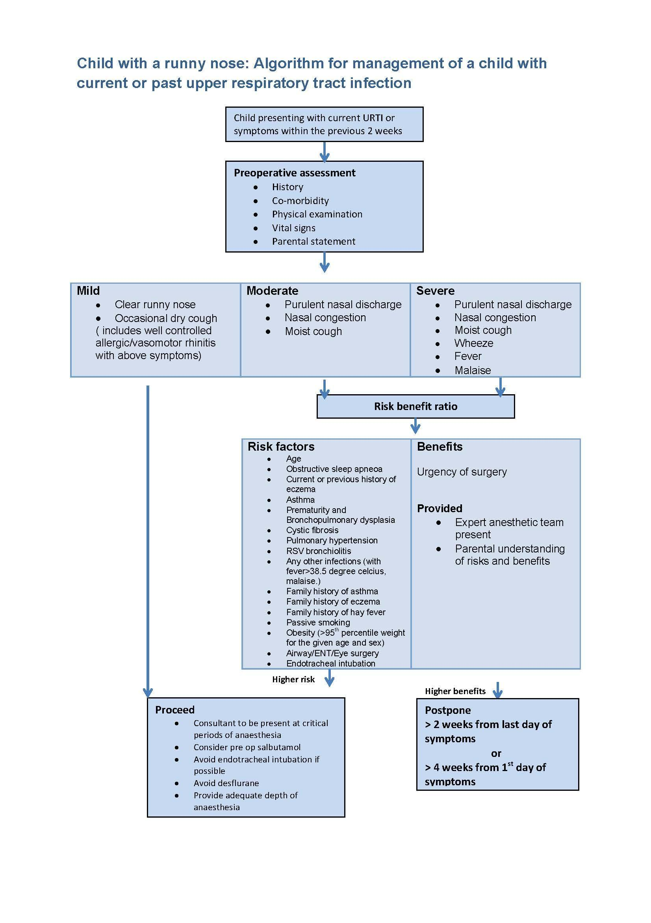

1. **The Wheezy Child**

All children coming for elective surgery should be free from signs and symptoms of acute asthma and ideally should be assessed 1-2 weeks before surgery. Ex-premature infants with Chronic Lung Disease may have hyperactive airways and still be on home oxygen therapy. Ascertain the frequency of attacks, severity of disease, usual precipitants of an asthmatic attack and current medical management. Respiratory function tests may be difficult to administer in younger children. The majority of cases are mild and precipitated by a respiratory tract infection.

The airways are more prone to bronchospasm within 6 weeks after an asthmatic attack. If there has been a recent exacerbation of asthma requiring emergency treatment or hospitalization, it may be prudent to postpone elective surgery. Severe asthmatics, particularly those who have had an ICU admission for asthmatic attack, should be reviewed and may need to be admitted for optimization of their condition by the Respiratory Physician before coming to the operating theatre. In these children with fragile asthma, non-steroidal analgesics and inhalational anaesthetics may precipitate an asthmatic attack. The risk of bronchospasm is also increased with endotracheal intubation.

If the child is on preventers like steroid inhalers, these should be continued in the perioperative period with the exception of theophylline that should be discontinued the night before. The child may benefit from pre-operative bronchodilator (MDI or nebuliser as appropriate) administration 20-30 min before anaesthetic induction. Consideration for administration of inhaled beta agonists like salbutamol on a regular basis 3-5 days before surgery can be given to children who take medication only during exacerbations. It is important to document the use of any inhalers given intra-operatively.

Children who have been taking more than 5 mg/day of prednisone for more than three weeks in the past year should either have the hypothalamic pituitary axis evaluated or, more commonly, should receive stress dose steroids prior to induction of anesthesia. For children who require endotracheal intubation for surgery and have poorly controlled asthma, consider a course of supplemental systemic glucocorticoid such as oral prednisolone 1 mg/kg (maximum 50 mg) once a day for 3 to 10 days or intravenous (IV) hydrocortisone 4 mg/kg (maximum 100 mg), every six hours in consultation with the respiratory physician.

In the majority of children with mild or well controlled asthma, general anaesthesia proceeds uneventfully and they can be discharged home or to the general ward. In children with more severe disease, particularly if bronchospasm has occurred intraoperatively, they may require monitoring and/or care in a High Dependency Unit or Intensive Care Unit postoperatively.

iii. The child with sleep disordered breathing (SDR) /obstructive sleep apnoea (OSA)

Sleep disordered breathing is common, affecting 10-12% of children and represents a spectrum from snoring to OSA.These children may be at risk of PRAE and should be identified early.

With OSA, there are frank apnoeic or hypnoeic episodes associated with oxygen desaturation and respiratory arousal, more commonly seen in REM (rapid eye movement) sleep rather than non-REM sleep. These episodes are not seen with primary snoring.

Polysomnography is the gold standard for diagnosis but rarely done.

The following table shows how severity of OSA according to polysomnography is defined by the American Society of Anesthesiologists Task Force on Perioperative Management of Patients with Obstructive Sleep Apnea:

| OSA severity | AHI children | AHI adults |
| --- | --- | --- |
| none | 0 | 0-5 |
| mild | 1-5 | 6-20 |
| moderate | 5-10 | 20-40 |
| severe | >10 | >40 |

Most children with SDR do not undergo polysomnography. As such alternative screening tools are used to identify children at risk of SDR. The tool used in our institution is the STBUR (Snoring Trouble Breathing UnRefresh) questionnaire.

The STBUR questionnaire asks for the following symptoms:

While sleeping, does your child

1) Snore more than half the time?

2) Snore loudly?

3) Have trouble breathing, or struggle to breathe?

4) Have you ever seen your child stop breathing during the night?

5) Does your child wake up feeling unrefreshed in the morning?

The presence of 3 or more symptoms is associated with a significant increased risk of PRAE by 3 fold or more.

OSA is associated with increased upper airway resistance during sleep with contributions from anatomical airway narrowing, abnormal airway muscle tone, and genetics predisposing children to obstructed breathing during sleep. Common risk factors associated with OSA include adenotonsillar hypertrophy, craniofacial malformations, hypotonia, obesity, midface hypoplasia, macroglossia, retrognathia, micrognathia, and glossoptosis. Syndromic children with OSA may have airway obstruction at multiple levels.

Untreated moderate/ severe OSA resulting in chronic severe hypoxemia may result in cardiovascular sequelae, including systemic and pulmonary hypertension and cor pulmonale. Children with OSA may also present with behavioral and neurocognitive disorders including attention deficit hyperactivity, poor school performance, enuresis, and headaches. The child’s growth may also be stunted, even though OSA is commonly associated with obesity. Some patients, especially those with neuromuscular conditions, may display mixed central (where there is absent respiratory effort and airflow) and obstructive sleep apnoea.

It is important to note how the child is being managed for OSA and if airway adjuncts such as bilevel positive airway pressure (BiPAP) or continuous positive airway pressure (CPAP), home monitoring, supplemental oxygen administration, and positioning during sleep are employed. If airway adjuncts are used, it is important that current settings be reviewed and that the device be available during recovery from anaesthesia.

The preoperative assessment should include review of the polysomnography results if any, noting the lowest oxygen saturation (SpO2) nadir. If the nadir SpO2 reaches 70% consider referring to a cardiologist to assess for cor pulmonale before proceeding with elective surgery.

Children with OSA may be more sensitive to the effects of general anaesthesia and sedation. Premedication is not encouraged and children who have received it must be constantly monitored.

Children with mod-severe OSA or a STBUR score of 3 or more should not be considered for day surgery.

These children are more prone to severe airway obstruction under anaesthesia. While dexmedetomidine and ketamine are associated with less airway obstruction and respiratory depression, opioids should be used with care in these children. Non-opioid based analgesia options are preferred in children with OSA.

1. **The child with a Cardiac murmur**

An incidental murmur may be picked up during the pre-operative visit. There is the need to differentiate between an innocent and pathological murmur.

Innocent murmurs are common and can be detected in children who are thriving well, active with no evidence of cyanosis, breathlessness at rest or on exertion. They are not associated with anatomical or physiological abnormalities. It is *usually* soft, grade1-3, early systolic and becomes softer with sitting up. It can also be continuous as in a venous hum.

Pathological murmurs are diastolic, pansystolic, late systolic, very loud murmurs with thrills, associated signs of cardiac disease or continuous murmurs (except venous hums) that persist regardless of body position. Concerning symptoms include respiratory difficulties, diaphoresis (especially with exertion), poor growth, poor feeding or excessive irritability in infants, chest pain and syncope.

Clinically it may be difficult to differentiate between innocent and pathological murmurs and referral to a cardiologist should be made preoperatively for elective surgery. All children with undiagnosed cardiac murmurs should have an ECG done and ideally, an echocardiogram done before surgery particularly if the child is less than 1 year old or has signs and symptoms of heart disease, evidence on the ECG of right or left hypertrophy and the murmur has characteristics of a pathological murmur. Under emergency conditions, because it is often difficult *clinically* to rule out small structural lesions, all children with murmurs should receive antibiotic prophylaxis prior to surgery that is likely to cause significant bacteraemia (dental,

genitourinary, oral or gastrointestinal) unless cardiac review has determined otherwise.

| **Features of Cardiac Murmurs in Children** | |
| --- | --- |
| **INNOCENT**  Asymptomatic  Soft, Grade 1-3  *Early Systolic  No Thrill  Becomes softer with sitting up | **PATHOLOGICAL**  Symptomatic  Loud  Pan / Late Systolic, Diastolic  Thrill  Remains constant regardless of body positioning |

* With the exception of venous hums which are continuous murmurs

1. **The child with challenging behaviour**

These children may be uncooperative and aggressive for various reasons (bad past anaesthesia experience, behavioural issues, psychological causes, acute medical illness resulting in abnormal brain function, mental retardation). It is useful to review the medical/ anaesthetic history of the child. Discuss with the parents / caregiver what factors affect behavior and what methods have worked in past anaesthetics (if any). If the child is very anxious due to multiple surgeries and anaesthetics, premedication given under direct supervision of the attending anaesthetist in the Children’s OT waiting area may be useful. (Please refer to the section under “premedication”)Alternatively, a child life specialist should be engaged early, perhaps weeks ahead of surgery to work with the child to enhance coping mechanisms and reduce anxiety.

1. **The Autistic child**

Children with autism have difficulty with communication, social interaction and imagination. They tend to have repetitive behavior like spinning and specific preferences with regards to what they like and dislike. They tend to view the world literally and may have difficulty coping with any change in routine or environment. Certain stimuli (sounds / sights / touch) may also trigger severe distress or meltdowns.

It is useful to have a workflow and toolkit that aims to identify children with autism early and aid parents in their preparation of these children for surgery. Having a record such as a “hospital passport” aids discussion with parents / caregivers about the triggers of meltdowns and the child’s usual coping mechanisms. It allows healthcare professionals to understand the child better like how the child communicates, takes medication etc. If the child has had previous anaesthetics, it is helpful to know methods that have worked well. These children may require premedication. Special considerations e.g. wearing their own clothes, having 2 parents at induction (especially for the older, larger child), early removal of IV cannula, recovery with parental presence in a quiet side area should be considered.

1. **The Child with Cerebral Palsy (CP)/ Brain damaged Child**

Children with CP will have motor deficits but may or may not have cognitive impairment. In both categories, venous access and patient positioning may be problematic due to disuse of limbs and contractures. Difficulty in swallowing, repeated episodes of pulmonary aspiration and possible kyphoscoliosis require careful assessment of the child’s respiratory status. Special measures to prevent pressure sores should be taken. If the child is on intermittent catheterization, the child may be at risk of latex allergy. Children with seizures should

have their anti-epileptic medications continued in the perioperative period as far as possible, although these have the potential for drug interactions with anaesthesia medications.

1. **The Child with Down’s Syndrome (Trisomy 21)**

| Pathophysiology &  Clinical Manifestation | Anaesthetic Implications |
| --- | --- |
| Microcephaly, macroglossia, hypotonia | Potential difficult airway  Exaggerated response to  NMBAs |
| Obstructive sleep apnoea Atlantoaxial instability | Loss of airway in post-op period  Consider need for pre-operative cervical spine X-ray  Caution with neck manipulation during airway management |
| Congenital subglottic stenosis | May need to downsize tracheal tube |
| Recurrent pulmonary infection  Congenital heart disease: ASD,VSD, AVSD, TOF, PDA,  pulmonary hypertension | Frequent cancellation of surgery  preop cardiac evaluation prophylactic antibiotics  profound bradycardia under general anaesthesia especially with sevoflurane |
| Duodenal atresia, gastroesophageal reflux | Emergency neonatal surgery  pulmonary aspiration risk |
| Endocrine disorders e.g.hypothyroidism | Endocrine workup and hormone replacement to continue perioperatively |
| Hematological disorders  e.g. leukemias, immunodeficiency | Predisposition to infection  need for frequent hospitalization |
| Central obesity | Positioning and pressure point protection  Predisposition to atelectasis |
| Difficult vascular access | Consider ultrasound guided vascular access |

Children with Down’s syndrome or Trisomy 21 present with multiple problems. Although some with this condition may be cognitively challenged and uncooperative at induction, it is important to realize that these children have varying degrees of cognitive function. Indeed, some are capable of holding intelligent conversations and cooperating with their doctors. The anaesthetic plan therefore needs to be tailored to the individual. Trisomy 21 children are often “floppy” (hypotonic) as infants and more prone to delayed recovery and airway obstruction.



Routine preoperative cervical spine X rays are generally not performed for asymptomatic children but should be done if clinically indicated.

*References:*

1. *Black AE. Medical assessment of the paediatric patient. British Journal of Anaesthesia 1999; 83(1):3-15.*
2. *Martin LD. Anesthetic Implications of an Upper Respiratory Infection in Children. Pediatric Clinics of North America 1994; 41(1): 121-130.*
3. *McCann ME, Kain ZN. The Management of Preoperative Anxiety in Children: An Update. Anesth Analg 2001; 93: 98-105.*
4. *McEwan AI, Birch M, Bingham R. The preoperative management of the child with a heart murmur. Paediatric Anaesthesia 1995; 5:151-56.*
5. *Rosenthal A. How to distinguish between innocent and pathologic murmurs in childhood. Pediatric Clinics of North America 1984; 31: 1229-1240.*
6. *Tait AR, Pandit UA, Voepel-Lewis T, Munro HM, Malviya S. Use of the Laryngeal Mask Airway in Children with Upper Respiratory Tract Infections: A Comparison with Endotracheal Intubation. Anesth Analg 1998; 86: 706-711.*
7. *Tait AR, Reynolds PI, Gutstein HB. Factors that influence an anesthesiologist’s decision to cancel elective surgery for the child with an upper respiratory tract infection. J Clin Anesth 1995; 7(6): 491-499.*
8. *Van Der Walt J. Anaesthesia in children with viral respiratory tract infection. Paediatric Anaesthesia 1995; 5:287-262.*
9. *Van der Walt JH, Moran C. An audit of perioperative management of autistic children. Paed Anaes. 2001; 11: 401-408.*